# 14. O MISTÉRIO DA EMPATIA (c)

Esse tema será desenvolvido com o vídeo linkado (16´): esse vídeo do min 34 ao min 50,24 (<https://youtu.be/vuubnNp_71k>)

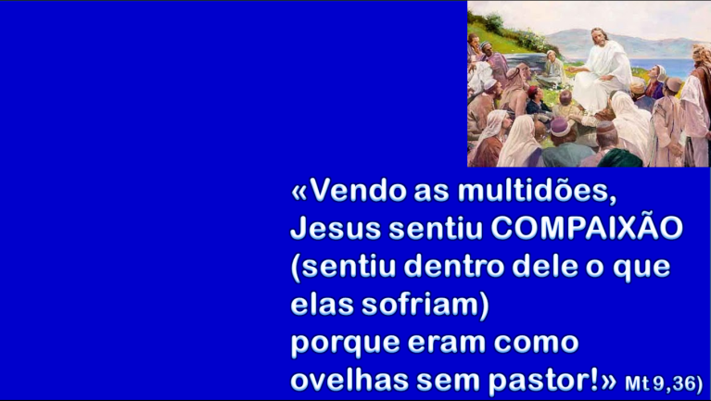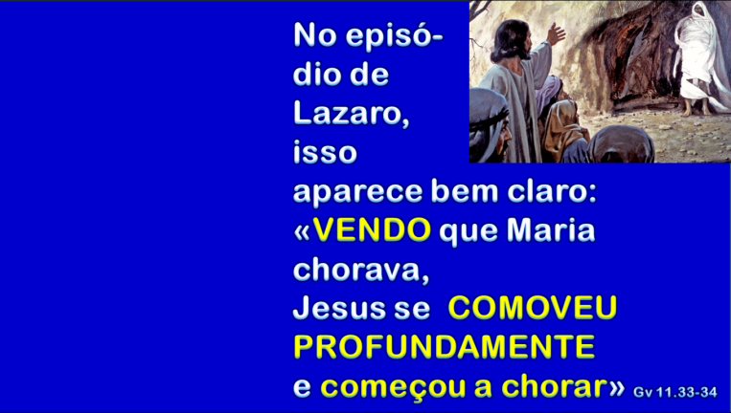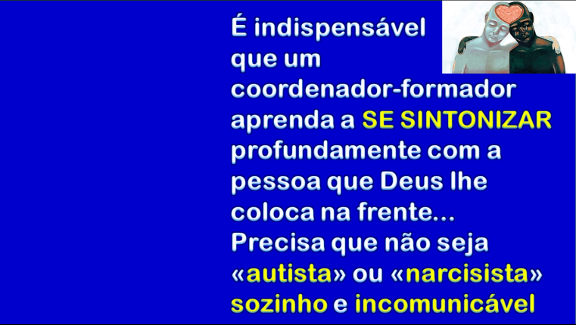

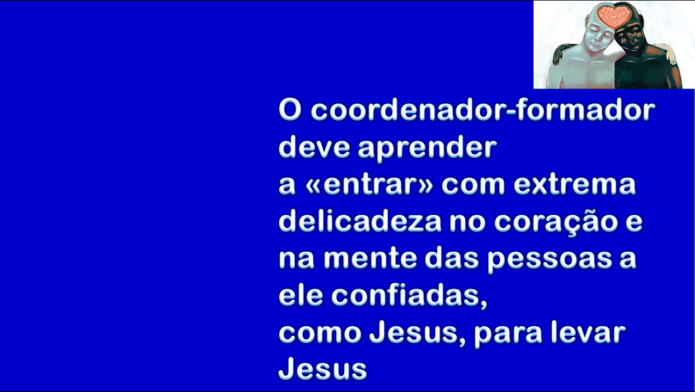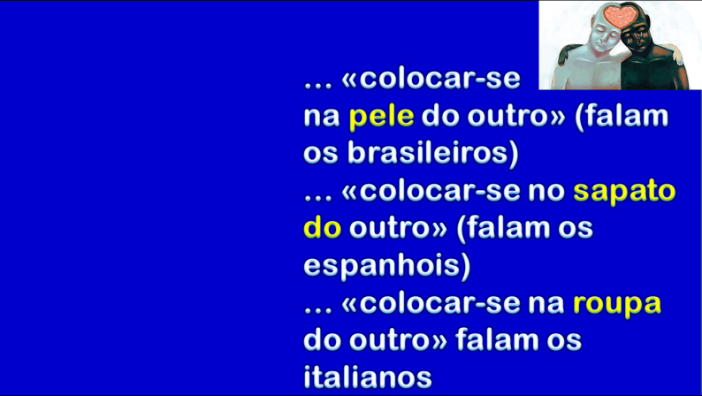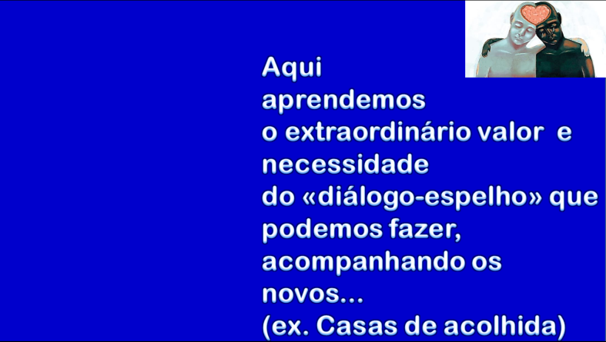

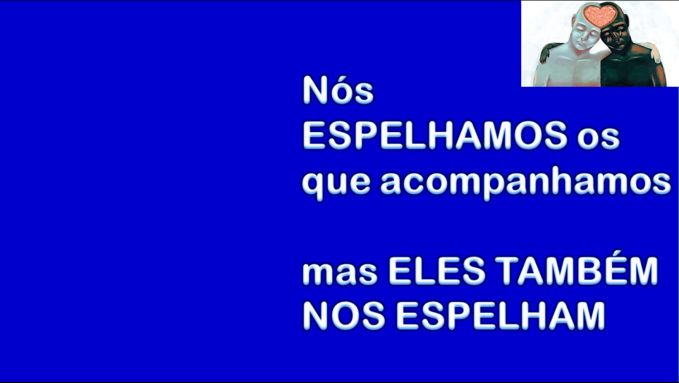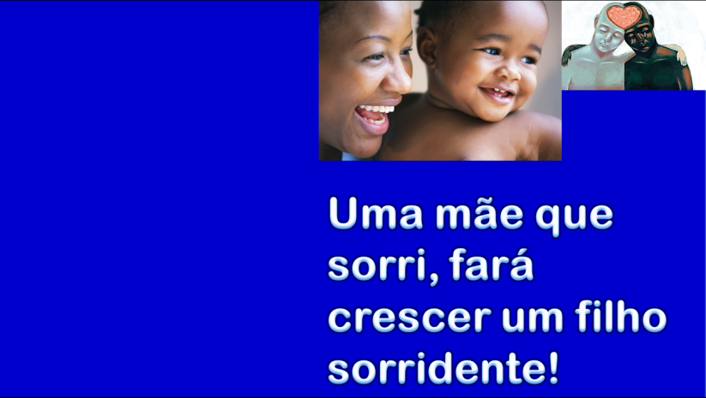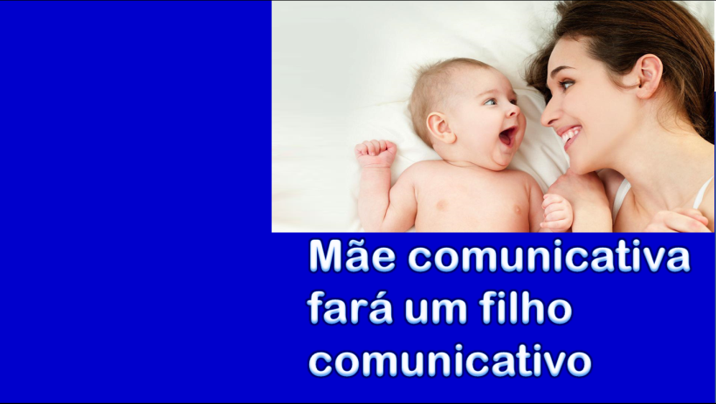

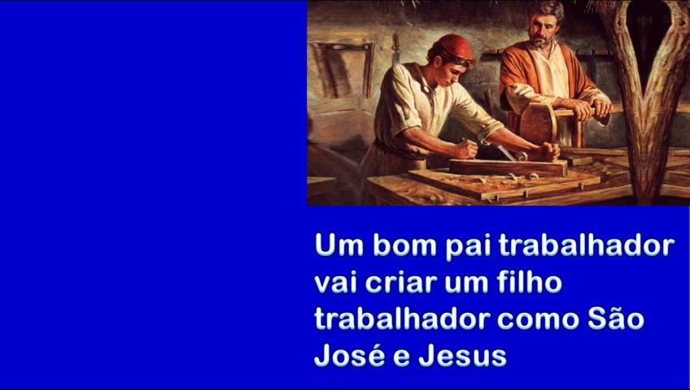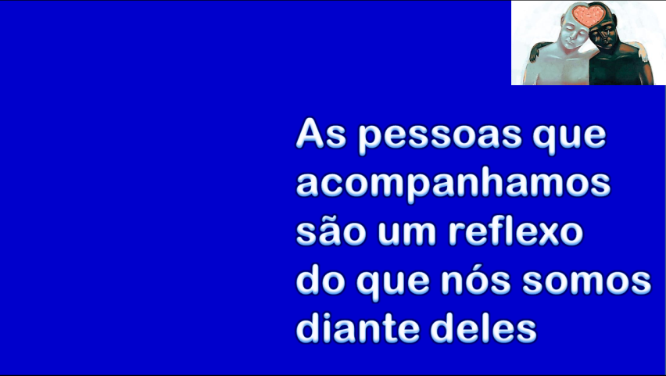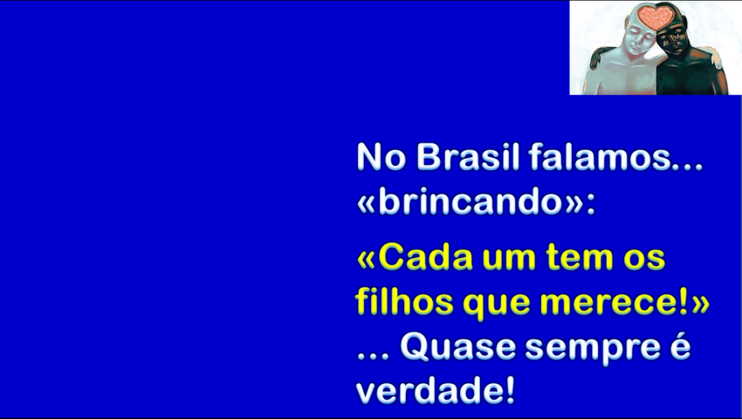

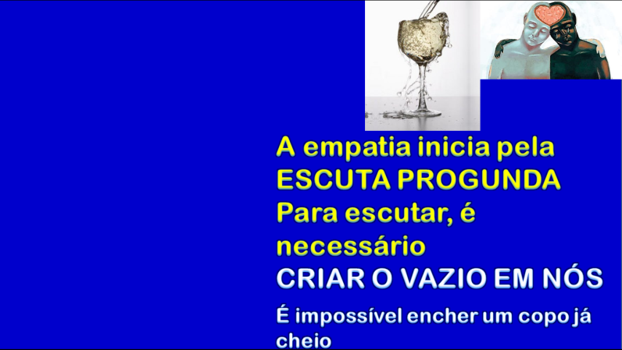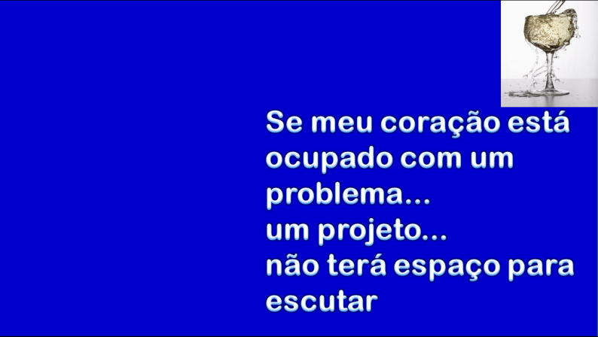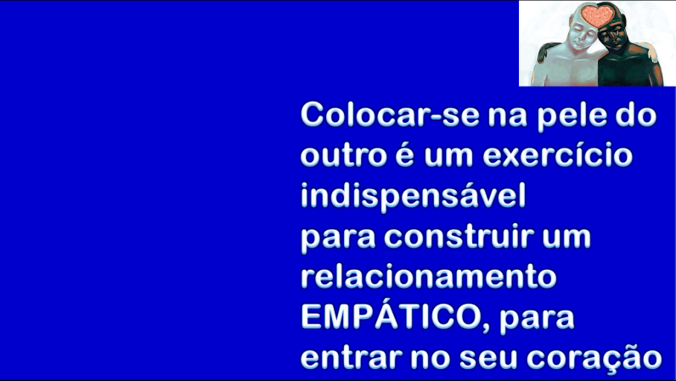

**A Empatia inicia pela ESCUTA PROFUNDA**

Sintetize com suas palavras esses 16´ de vídeo que você assistiu:

____________________________________________________________________________________

____________________________________________________________________________________

____________________________________________________________________________________

____________________________________________________________________________________

____________________________________________________________________________________

____________________________________________________________________________________

____________________________________________________________________________________

____________________________________________________________________________________

____________________________________________________________________________________

____________________________________________________________________________________

____________________________________________________________________________________

____________________________________________________________________________________

____________________________________________________________________________________

____________________________________________________________________________________

____________________________________________________________________________________

____________________________________________________________________________________

____________________________________________________________________________________

____________________________________________________________________________________

____________________________________________________________________________________

____________________________________________________________________________________

Nome inteiro em letra de forma de quem faz a prova: _______________________________________________________

Data da prova ____________________ Assinatura: ___________________________________________________________

Nome inteiro (em letra de forma) de quem faz a prova: ______________________________________________________

Frat. __________________________________Data da prova __________ Assinatura: _____________________________________

PROVA N. 14