# 13. O MISTÉRIO DA EMPATIA (b)

Esse tema será desenvolvido com o vídeo linkado (20´): esse vídeo do min 14,43 ao min 34 (<https://youtu.be/vuubnNp_71k>)

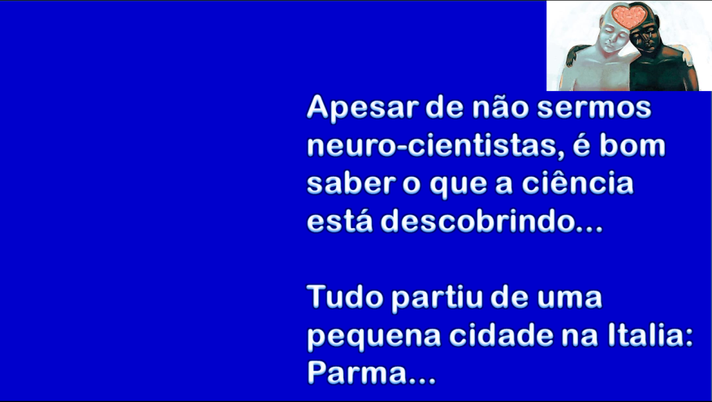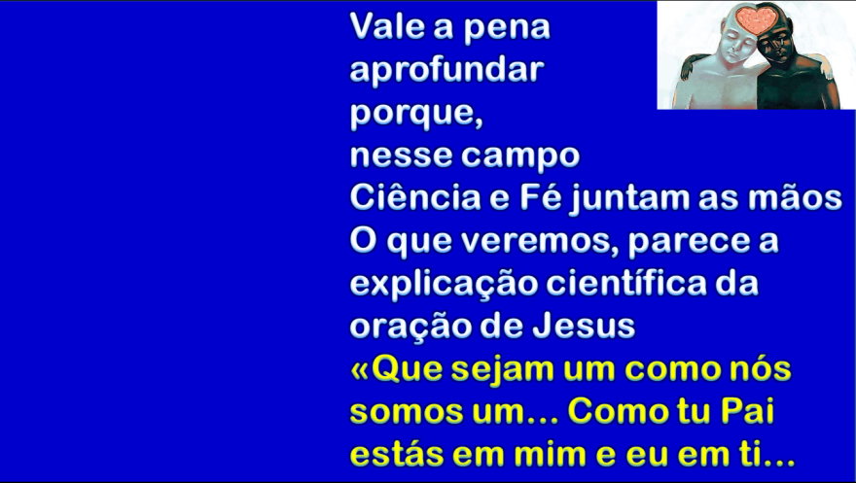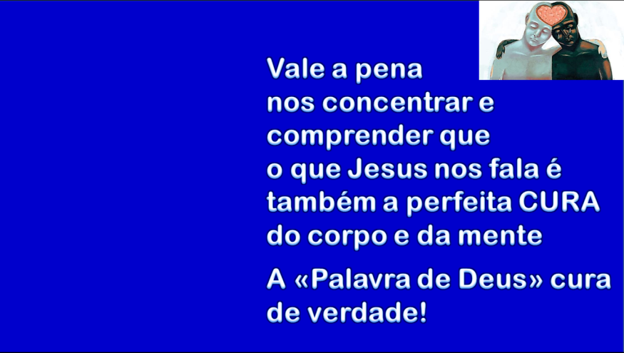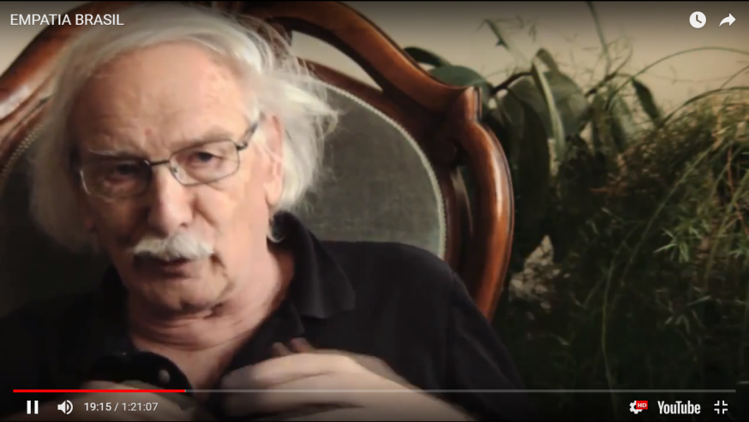

Sintetize com suas palavras esses 20´ de vídeo que você assistiu, sobretudo o discurso do cientista:

____________________________________________________________________________________

____________________________________________________________________________________

____________________________________________________________________________________

____________________________________________________________________________________

____________________________________________________________________________________

____________________________________________________________________________________

____________________________________________________________________________________

____________________________________________________________________________________

____________________________________________________________________________________

____________________________________________________________________________________

____________________________________________________________________________________

PROVA N. 13

____________________________________________________________________________________

Nome inteiro (em letra de forma) de quem faz a prova: _______________________________________________________

Frat. __________________________________Data da prova __________ Assinatura: _____________________________________