# 12. O MISTÉRIO DA EMPATIA (a)

Esse tema será desenvolvido com o vídeo linkado (15´): esse vídeo até o min 12,42 (<https://youtu.be/vuubnNp_71k>)

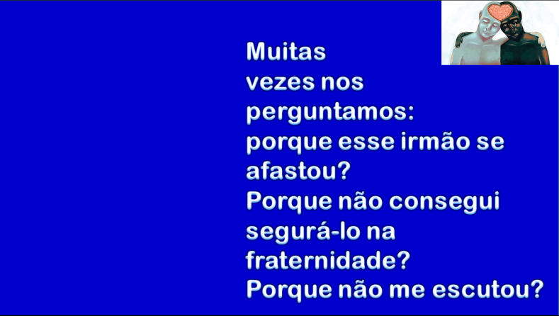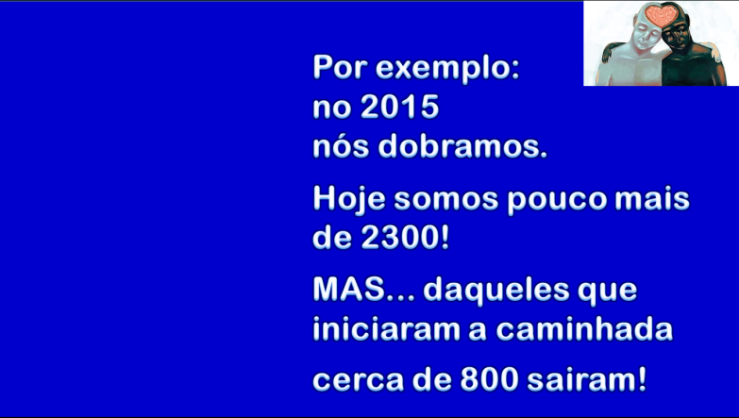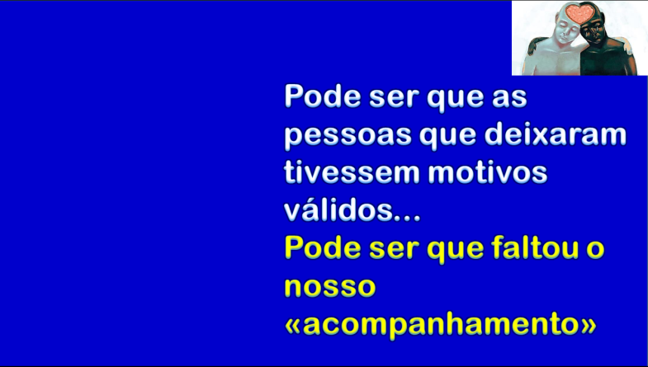

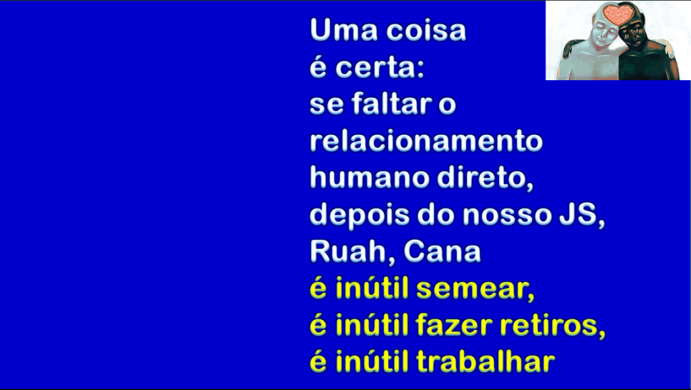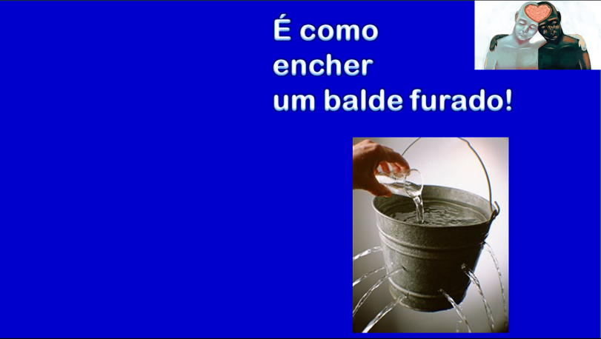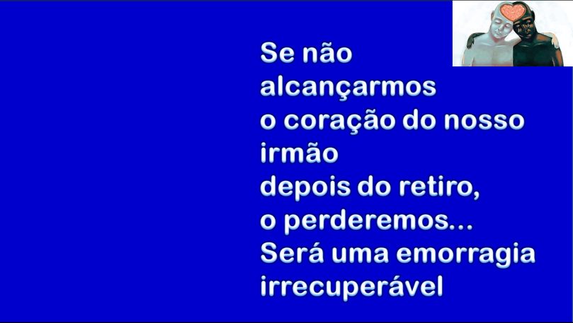

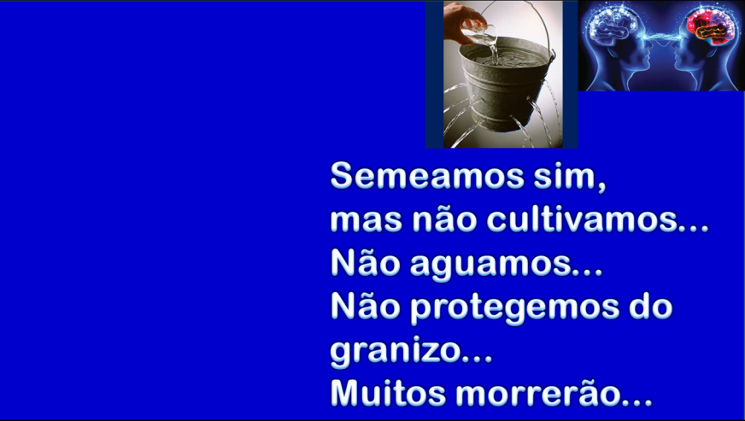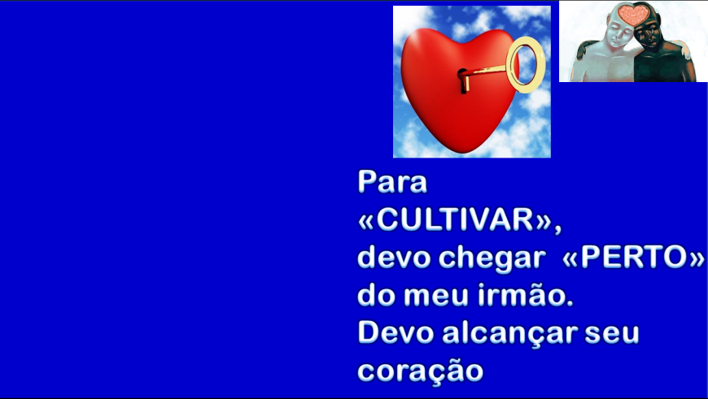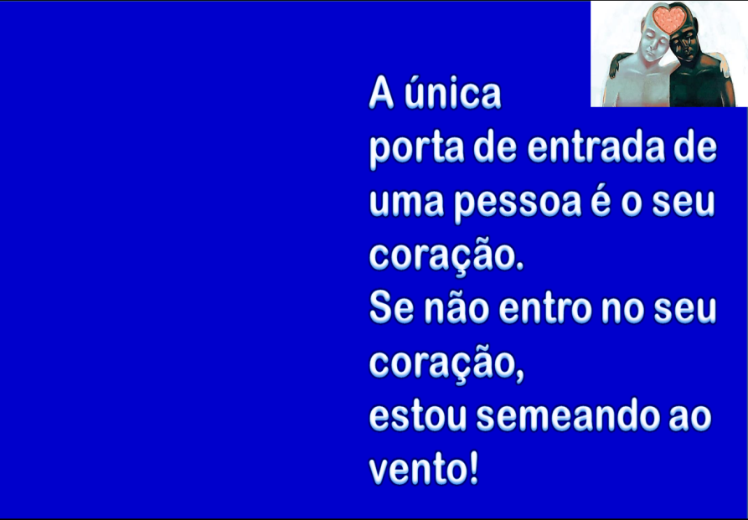

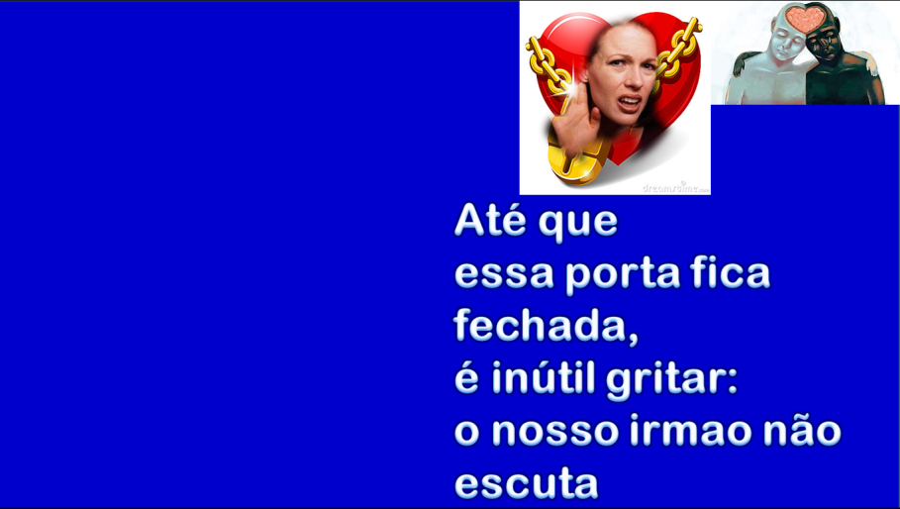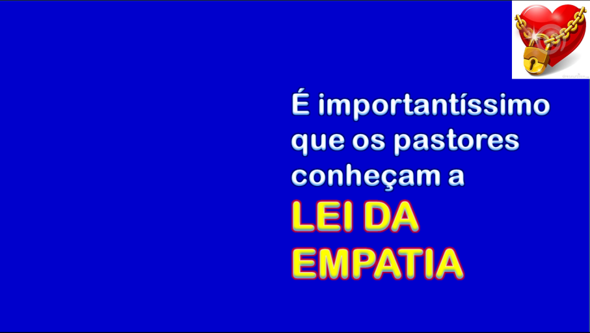

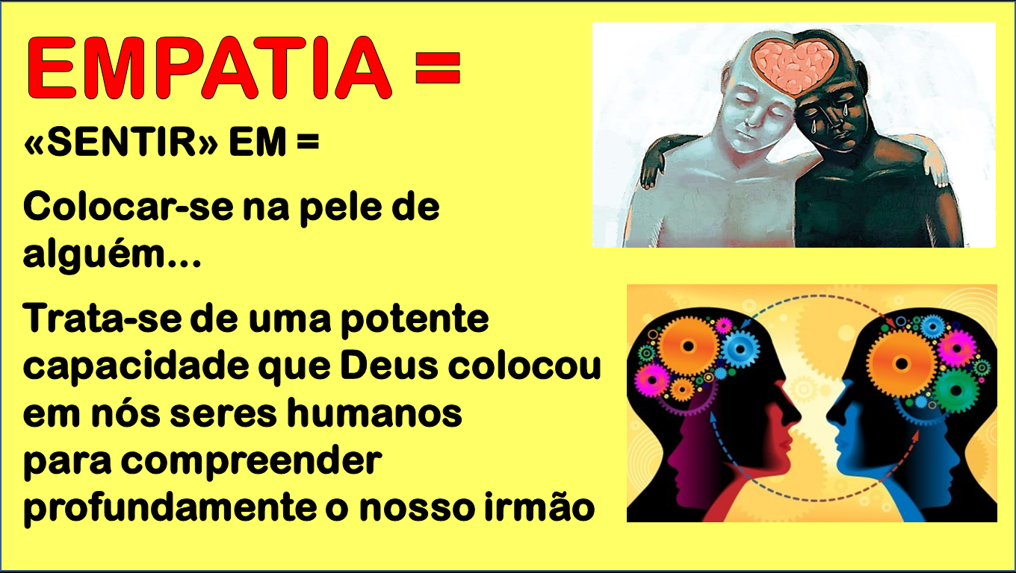

Sintetize com suas palavras esses primeiros 15´ de vídeo que você assistiu

____________________________________________________________________________________

____________________________________________________________________________________

____________________________________________________________________________________

____________________________________________________________________________________

____________________________________________________________________________________

____________________________________________________________________________________

____________________________________________________________________________________

____________________________________________________________________________________

____________________________________________________________________________________

____________________________________________________________________________________

____________________________________________________________________________________

____________________________________________________________________________________

____________________________________________________________________________________

____________________________________________________________________________________

____________________________________________________________________________________

Nome inteiro (em letra de forma) de quem faz a prova: ______________________________________________________

Frat. __________________________________Data da prova __________ Assinatura: _____________________________________

PROVA N. 12